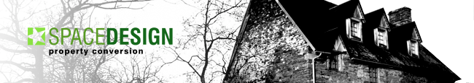

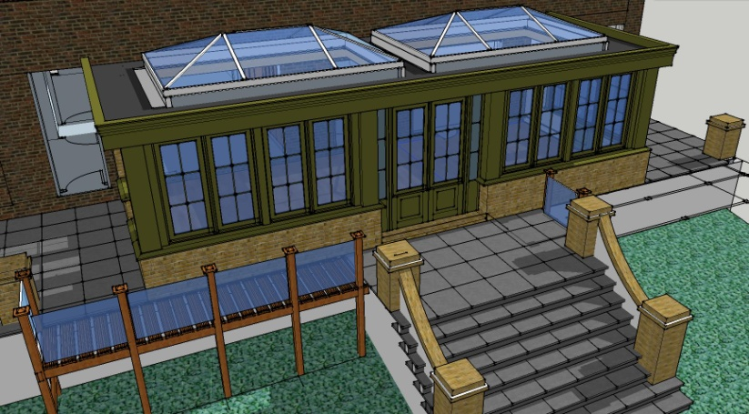
Case Study – Conservatory/Orangery, Kent
Brief – To design and plan options for a space that would form a natural extension of the central kitchen to the rear of the double fronted house, without a major reduction in natural light.
Scheme Design – The obvious choice was an Orangery type building with twin raised lantern arrangement to maximise light into the main house. The predominately timber framed windows and door sets to provide a “Pavilion” appearance. The setting out of the floor plan was dictated by a modular size for the window bays to minimise costly purpose made joinery repetition.
Scope of work – Produce fully detailed CAD drawings for submission of full planning and building control applications, with detailed specifications, cost spread sheets and outline programme.
On successful receipt of local authority approvals project manage and supervise the building works through to completion.

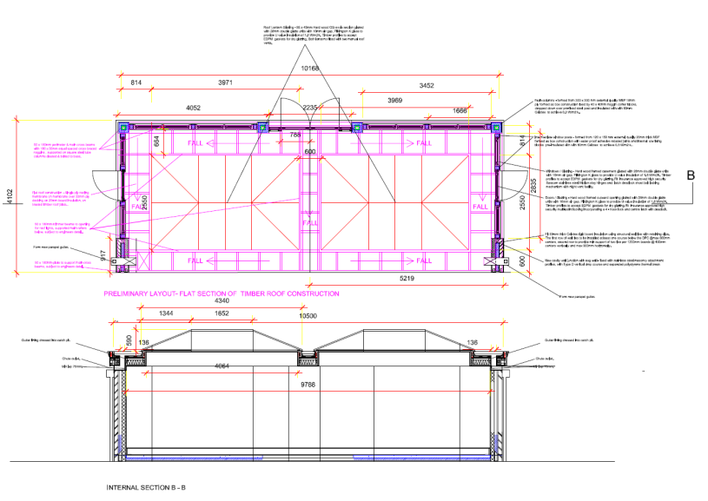
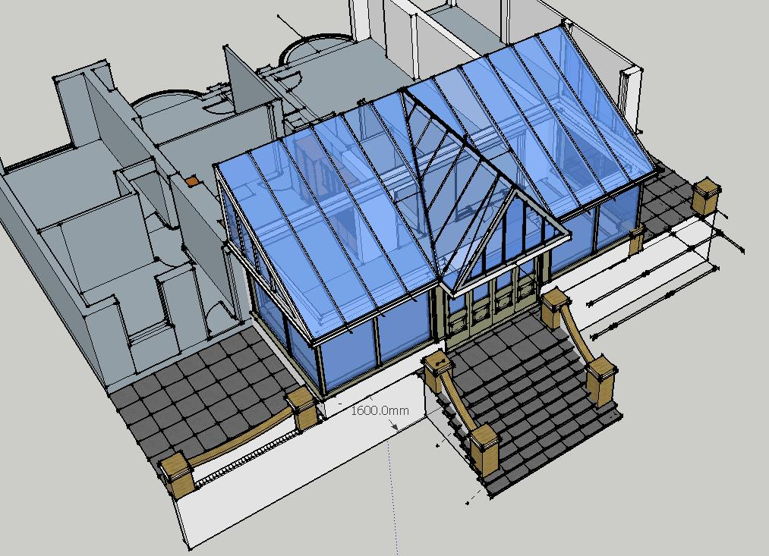
Spacedesigneurope
M : +44 [ 0]7710 402 457
Email: john@spacedesigneurope.co.uk
www.spacedesigneurope.co.uk

